Communication Manager running on virtual platform: CM6
Run the following reports and copy and paste into a single text (.txt) file (DO NOT USE SCREEN SHOTS PLEASE):
- From shell:
- swversion
- statuslicense –v
- server
- cat /proc/mdd (If it’s a duplicated CM : S8700 or S8800)
- From sat:
- display system-parameters customer-options
- display capacity
- list cabinet (See note 1 below)
- list media-gateway (See note 1 below)
- list configuration all
- list survivable-processor (See note 1 below)
- list node-names all
- display locations

- from shell logon into dom0 with root right and run:
- cd /usr /sbin
- dmidecode -t system
- ifconfig –a (this one is better to be run from cdom as well)

Note 1) “list cabinet”, “list media-gateway”, “list survivable-processor” might fail due to several possible system configurations. In these specific cases, error messages will be: “"cabinet" is an invalid entry”, ““media-gateway” is an invalid entry” and “No records match the specified query options”. If such a message appears, skip to next step.

CM: S87xx/S85xx/S88xx/S83xx CM1, CM2, CM3, CM4, CM5 (Any versions elder than CM5 are EOS)
Please ensure the system reports are pulled from the core system (e.g. MID = 1) and not from an attached ESS or LSP.
Run the following reports and copy and paste into a single text (.txt) file (DO NOT USE SCREEN SHOTS PLEASE):
- From shell:
- swversion
- statuslicense –v
- server
- cat /proc/mdd (If it’s a duplicated CM : S8700 or S8800)
- From sat:
- display system-parameters customer-options
- display capacity
- list cabinet (See note 1 below)
- list media-gateway (See note 1 below)
- list configuration all
- list survivable-processor (See note 1 below)
- list node-names all
- display locations

Note 1) “list cabinet”, “list media-gateway”, “list survivable-processor” might fail due to several possible system configurations. In these specific cases, error messages will be: “"cabinet" is an invalid entry”, ““media-gateway” is an invalid entry” and “No records match the specified query options”. If such a message appears, skip to next step.

EMMC (Extended Meet-me Conference)
- swversion
- ifconfig –a / ifconfig eth0

System Manager (SMGR)
- swversion
- ifconfig eth0
- dmidecode -t 1
- cat /etc/hosts (not necessary just additional info)
Session Manager (SM)
- swversion
- smconfig
- dmidecode -t 1

Session Boarder Controller (for Enterprise)
- config show –v
- show interfaces
- config box interface eth0 show

Avaya Contact Centre Control Manager
Licensed on the CM, please obtain the License Host ID referring to this product.

Definity / G3R V6-10 Reports(All are EOS)
Run the following reports and copy and paste into a single text (.txt) file (DO NOT USE SCREEN SHOTS PLEASE):
- list configuration software-versions long
- status spe
- display system-parameters customer-options
- display capacity
- list cabinet
- list configuration all
- display locations

Definity / G3si V6-10/ G3csi V6-10 Reports (All are EOS)
Run the following reports and copy and paste into a single text (.txt) file (DO NOT USE SCREEN SHOTS PLEASE):
- list configuration software-versions long
- list configuration control
- display system-parameters customer-options
- display capacity
- list configuration port-network
- list configuration all
- display locations
Definity Audix (All are EOS)
- list configuration
- display system-parameters customer-options
- display system-parameters maintenance
Intuity Audix
Write at prompt: ‘System Evaluation Report’ (from Web Interface) or if you don’t have web interface than from system prompt:
- Intuity UNIX_SV% syseval
- Intuity UNIX_SV% cat /mtce/login/tsc/syseval.d/syseval.out

Intuity Audix LX
Write at prompt: ‘System Evaluation Report’ (from Web Interface)

MM 4.0 or above

- Access the Remote Desktop of the MAS computer {it is either win2000 or win 2003 server}
- Go to WINDOWS START menu and start the following program under Avaya/Modular Messaging> Voice Mail System Configuration (VMSC).
- It will show a tree structure. Count the number of MASs and check the Host ID with following command> {Right click} Copy HOST ID to clipboard ---- open a notepad, Ctrl+V. System ID is good as well, if it is easier to access.

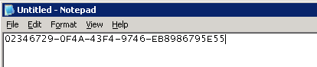

- Log on to the MAS server’s WebLM interface and make a screenshot of the messaging system’s Host ID (next to License File Host IDs)

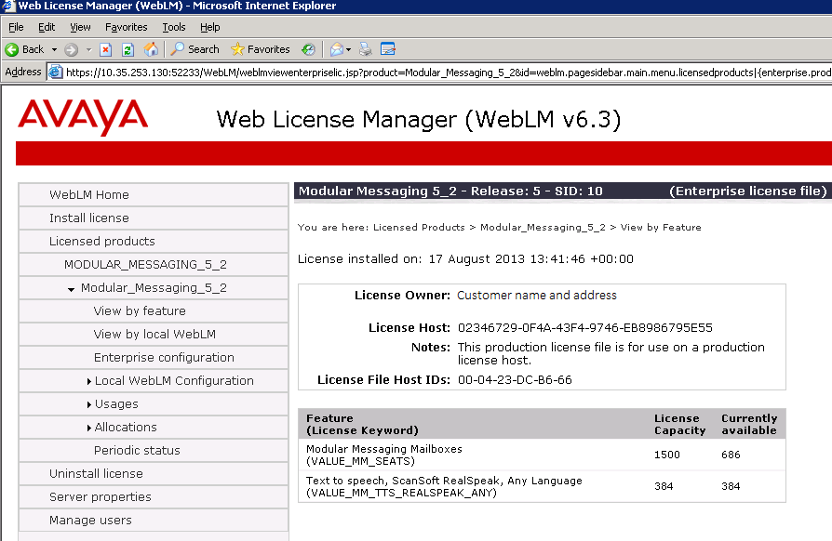

- For determining hardware run command chassis_type from MSS server linux interface (with root right)

MM 3.1 or below (All are EOS)
- Need the mailbox licence number
- Number of MAS and type (S3400/S3500)
- Qty of trunk boards if applicable
- Number of MSS if applicable and type (S3400/S3500) Standard or High Availability configuration
- Release (R1.1, R2, R3 etc)
See embedded document for screen shots to assist:

Avaya Aura Messaging (AAM)
Please check who sold the server and whether need server coverage or not.
Please run the following commands:
- swversion

from VMSG’s cdom AND dom0 run:
- ifconfig –a
- dmidecode –t system (this requires root right)

Communication Manager Messaging (CMM)
The successor of IA770: is always co-resident with CM. Its version and patches show using the
- swversion
command on the Linux shell, result example:

Messaging: +-N3.1-26.3---Ck+Ab-----

CMS
Since R17 we have both of Solaris and Linux based systems we need 2 different report set as well. In case of CMS R16 or elder we need only the Solaris column.

Solaris based system | Linux based system | Note
pkginfo –x cms | rpm –q cms | CMS sw. version query
cmssvc > option 1 | cmssvc > option 1 | Authorization details (need root right to run this)
/usr/sbin/prtdiag -v | dmidecode | grep Serial Number  dmidecode | grep Product Name: | Hw details (need root or sroot right to run this in case of Linux)
Remark: the serial number is very important for hw. maintenance!
Performance Center / IQ
You can verify the licenses install on IQ via weblm:
Login into weblm by using following link:
https://IPaddress_of_IQ_ADMIn_Host:4883/WebLM

… or from shell:
- ssh craft@<IP address>
The command prompts that could be run on the server are located in the sbin folder.
- /sbin/ifconfig –a list of the eth ports with details
- /sbin/chkconfig –-list IQ configuration settings

IVR (All are EOS)
Scan.out capture:
V6-V7 (Map40 / Map100): Run Scan Tool, At the # prompt in this directory enter chmod 555 scan77b
V8 & IR R1.1-2.0 (UCS1000, Sunblade 150, Sunfire V240 / 280R): show_sys, RTUquery, uname –a
IC
Need the license file from one of license servers from the following directory: {ICHOME}\comp\weblm\licenses\sxxxxxxxxxxlicense.xml file. - > into zip file
OA
- oalist output
VP
Need the license file from WebLM server (<tomcat_home>/webapps/WebLM/licenses/xxxxxx.xml). (THIS FOLDER CONTAINS ONLY ONE FILE IN NORMAL CIRCUMSTANCES) into zip file. Please don’t download it from MPP servers, but from VPMS or from the company wide licence server.
AAEP
Similar to VP need the license file or please obtain the License Host ID.
Call Back Assist R4 and Proactive Outreach Manager R2
CBA R4 and POM R2 are licensed on the VP/AAEP. Please obtain the License Host ID for these products. *same as VP/AAEP license Host ID.
APC/PDS
Need the following config files> /opt/avaya/pds/etc/master.cfg, and /opt/avaya/pds/config/dgswitch.cfg
In case of 12.0 and 3.0 for more information about hardware write in the shell with root right: # sam > Performance Monitors > System Properties > copy to txt file.
In case of version 4.x and above need to run: “dmidecode | grep Product Name:” (need root right to run this) for hw type of main server of PDS and need to have the Licence HOST ID as well for detailed licensing.
Checking the cards in PG230: telnet from the server: >telnet switch1 -→ in the PG230: login: admin with this way you can reach the following view (follow the yellow /bold parts) :

A D M I N I S T R A T O R M A I N M E N U

Generic Version.Revision 18.1.4

A) Data Base Administration Menu
B) System Configuration Menu
C) Maintenance Menu
D) Diagnostics Menu

Enter Selection: C

M A I N T E N A N C E M E N U

A) Card Maintenance
B) Disk Utilities
C) Print/Display System Log File
D) Print/Display System Trace File
E) Switch ACT System To SBY
F) Master Timing Link Selection
G) Card Alarm Display
H) System Alarm Display
I) Shutdown System

Enter Selection: A

C A R D M A I N T E N A N C E

R L S CARD TYPE V.RV S R L S CARD TYPE V.RV S
-------- ---------------------- ----- - - - ---- ---------------------- ----- -
1 1 1 Enhanced Network Bus 15.02 A 1 1 20-1 4-Span Quad E1 PRI-120 13.00 U
1 1 3-1 Tone Generator DSP2-41 1.02 A 1 1 20-2 4-Span Quad E1 PRI-120 13.00 U
1 1 3-2 Conference DSP2-41 1.02 A 1 1 20-3 4-Span Quad E1 PRI-120 13.00 U
1 1 3-3 Call Progress DSP2-41 1.02 A 1 1 20-4 4-Span Quad E1 PRI-120 13.00 A
1 1 3-4 Call Progress DSP2-41 1.02 A
1 1 4 Large Port Voice Card2 1.01 A
1 1 15-1 4-Span Quad T1 PRI U
1 1 15-2 4-Span Quad T1 PRI U
1 1 15-3 4-Span Quad T1 PRI U
1 1 15-4 4-Span Quad T1 PRI U

A)DD, D)ELETE, C)HANGE, P)ORT: _ _ _ ____ ______________________ PORTS: ___ _
1- 64: ________ ________ ________ ________ ________ ________ ________ ________
65-128: ________ ________ ________ ________ ________ ________ ________ ________
129-192: ________ ________ ________ ________ ________ ________ ________ ________
193-248: ________ ________ ________ ________ ________ ________ ________

In case of Customer has a “POD” installation we need to have the License host or related HOST ID by all means. POD means: several APC systems working together in one network. In this case we can handle them only together and not one by one.

AES (lower than version CM5.2.1) /AES 3.1-AES 5.0/
Determine the Host ID or SID number of the AEs servers and copy paste it to a txt. file
Commands:
- swversion (Use "swversion [-a | --all]" to get a complete list of AE Services RPMS and Patches/Updates)
- ifconfig -a (with root right)
AES (from version 5.2) from shell:
- swversion (Use "swversion [-a | --all]" to get a complete list of AE Services RPMS and Patches/Updates)
- ifconfig -a (needs to be run from AES’s cdom with root right)
- dmidecode -t 1 (from AES’s sdom)

CCS
- hardware_info or inventory
- swversion
CCE
- Remote Desktop to the CCE Core Server
- Start the CCE Control Panel
- Navigate to
- License Directors
- License Keys
- copy out to a text file - each available License Key individually:
- The license keys can be found in PLDS under “Host ID”-s.

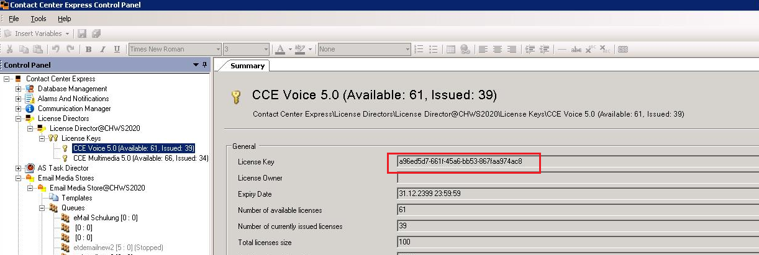
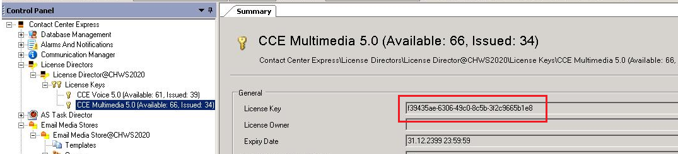

Call Center Elite Multichannel R5-R6 (CCM)

Please obtain the correct License Host ID and sent it to me.

Conferencing / MX /Meeting Exchange

I need the Local Area Connection Physical Address: this the Host ID ->
Run CMD from start menu -> ipconfig /all - and send me the full report in txt file!
DECT R4
- Go to Diagnostics page and select the Service Report tab
- Download the service report,copy into a txt file and send to me.
OEM Maintenance

Eaton (UPS)

Please obtain all the Equipment type with the related serial numbers per site including full site address.
/e.g.: Type:9136 6kVA, serial number: CB413A8017

Inisoft (SYNTELATE) (Webagent, Supervisor, Enetrprise Agent)

Please obtain the number of licenses per installed products.

Loquendo (belong to Nuance already)

Please obtain the PIK (Product Installation Key) code, as unique identification code.

Nuance

Please obtain the License Authorization Code (LAC), as unique identification code. (For example: OR14381-2626943)

NICE (No support from middle of 2014)

We need the logger ID, as unique identification code, which can be found here on the logger:

D:\NTLogger\Log or
D:\Program files\NTLogger\Log

- Open the log file and the first lines contain the Logger ID:

“NICE Digital Logger - Ver 9.6.05.53 Ver Date 10/09/2008 14:05 (72442301) INFO: !!! Buffer, Place = 2 3180 11/30/2012 11:07:38 PM
…”
Verint Witness ContactStore (No support under version R12)

Please obtain the PAC, as unique identification code for the Verint Witness CS. Under the System settings under License Menu you can find all the Licenses related information. See the below picture

The PAC is actually called System Serial number (old) / Recorder number (newer systems) . In the below example: 811411.
